1

#include<stdio.h>

void main()

{

FILE * fp1;

FILE * fp2;

fp1=fopen("filetest.cpp","r");

fp2=fopen("filetest.cpp","r");

char buffer[256];

fscanf(fp1,"%s",buffer);

printf("%s\n",buffer);

fscanf(fp2,"%s",buffer);

printf("%s\n",buffer);

printf("fp1(filetest.cpp):%d\n",fp1->_file);

printf("fp2(filetest.cpp):%d\n",fp2->_file);

printf("stdin:%d\n",stdin->_file);

printf("stdout:%d\n",stdout->_file);

printf("stderr:%d\n",stderr->_file);

}

#include<stdio.h>

int main()

{

printf("Hello World!\n");

return 0;

}

结果：

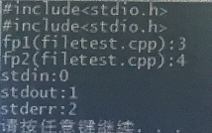

2

#include<stdio.h>

int main(){

int account;

char name[30];

double balance;

FILE * cfPtr;

if((cfPtr=fopen("clients.dat","w"))==NULL)

{

printf("File could not be opened\n");

}

else{

printf("enter the account ,nameand the balance:\n");

printf("enter EOF to end input.\n");

printf("?");

scanf("%d%s%lf",&account,name,&balance);

while(!feof(stdin))

{

fprintf(cfPtr,"%d%s%.2f\n",account,name,balance);

printf("?");

scanf("%d%s%lf",&account,name,&balance);

}

fclose(cfPtr);

}

return 0;

}

结果：

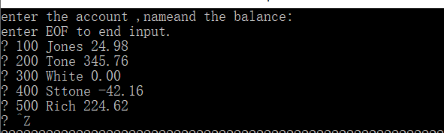

3

#include<stdio.h>

int main()

{

int account;

char name[30];

double balance;

FILE * cfPtr;

if((cfPtr=fopen("clients.dat","r"))==NULL)

{

printf("File could not be opened\n");

}

else{

printf("%-10s%-13s%s\n","Account","Name","Balance");

fscanf(cfPtr,"%d%s%lf",&account,name,&balance);

while(!feof(cfPtr))

{

printf("%-10d%-13s%lf\n",account,name,balance);

fscanf(cfPtr,"%d%s%lf",&account,&name,&balance);

}

fclose(cfPtr);

}

return 0;

}

结果：

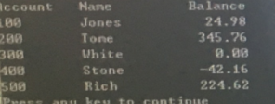

4

#include<stdio.h>

struct clientData

{

int acctNum;

char lastName[15];

char firstName[10];

double balance;

};

int main(){

int i;

struct clientData blankClient={0,"","",0.0};

FILE * cfPtr;

if((cfPtr=fopen("credit.dat","wb"))==NULL)

{

printf("File could not be opened\n");

}

else{

for(i=1;i<=100;i++)

{

fwrite(&blankClient,sizeof(struct clientData),1,cfPtr);

}

fclose(cfPtr);

}

return 0;

}

5

#include<stdio.h>

struct clientData

{

int acctNum;

char lastName[15];

char firstName[10];

double balance;

};

int main(){

int i;

struct clientData client={0,"","",0.0};

FILE * cfPtr;

if((cfPtr=fopen("credit.dat","rb+"))==NULL)

{

printf("File could not be opened\n");

}

else{

printf("enter account number(1 to 100.0 to endinput):\n");

scanf("%d",&client.acctNum);

while(client.acctNum!=0)

{

printf("enter lastname,firstname,balance\n");

fscanf(stdin,"%s%s%lf",client.lastName,client.firstName,&client.balance);

fseek(cfPtr,(client.acctNum-1)*sizeof(struct clientData),SEEK_SET);

fwrite(&client,sizeof(struct clientData),1,cfPtr);

printf("enter account number:\n");

scanf("%d",&client.acctNum);

}

fclose(cfPtr);

}

return 0;

}

结果：

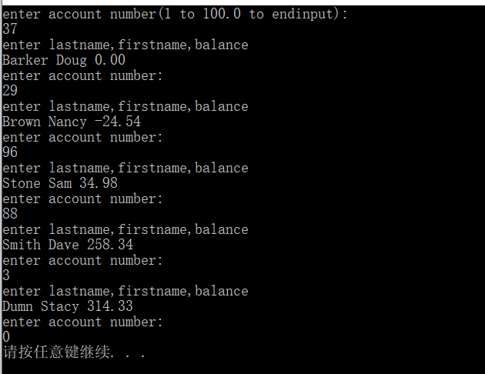

6

#include<stdio.h>

struct clientData

{

int acctNum;

char lastName[15];

char firstName[10];

double balance;

};

int main(){

struct clientData client={0,"","",0.0};

FILE * cfPtr;

if((cfPtr=fopen("credit.dat","rb"))==NULL)

{

printf("File could not be opened\n");

}

else{

printf("%-6s%-16s%-11s%10s\n","Acct","LastName","FirstName","Balance");

while(!feof(cfPtr))

{

fread(&client,sizeof(struct clientData),1,cfPtr);

if(client.acctNum!=0)

{

printf("%-6d%-16s%-11s%10.2f\n",client.acctNum,client.lastName,client.firstName,client.balance);

}

}

fclose(cfPtr);

}

return 0;

}

结果：

